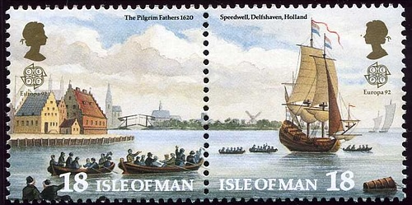
Society of Mayflower Descendants
in the State of North Carolina
Speedwell Colony
I, the undersigned, a member in good standing of a member society of the General Society of Mayflower Descendants, apply for associate membership in “The Speedwell Colony of the Society of Mayflower Descendants in the State of North Carolina.”
Signature: ________________________________
Name (printed): ________________________________
Address: ________________________________
________________________________
Membership Numbers: GSMD ___________
Member Society ___________
Date: ________________________________
E-mail address: ________________________________

A scanned copy can be sent as a .pdf by e-mail to:
wbsoule1620@gmail.com
or printed out and sent by regular mail to: W. Becket Soule
PO Box 1359
Maggie Valley, NC 28751

