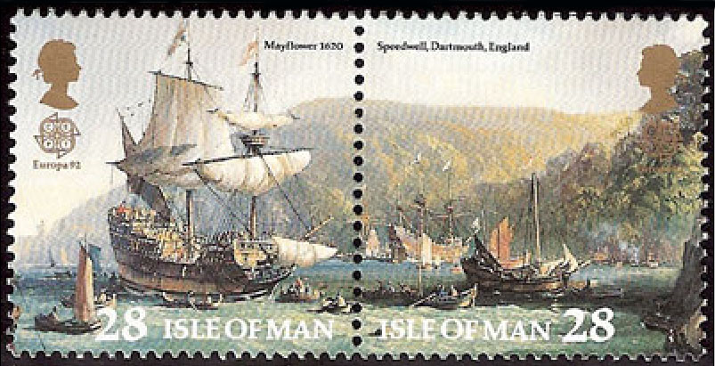
Society of Mayflower Descendants
in the State of North Carolina
Speedwell Colony
I, the undersigned, a member in good standing of the Society of Mayflower Descendants in the State of North Carolina, apply for membership in “The Speedwell Colony of the Society of Mayflower Descendants in the State of North Carolina.”
Signature: ________________________________
Name (printed): ________________________________
Address: ________________________________
________________________________
Membership Numbers: GSMD ___________
SMDNC ___________
Date: ________________________________
E-mail address: ________________________________

A scanned copy can be sent as a .pdf by e-mail to:
wbsoule1620@gmail.com
or printed out and sent by regular mail to: W. Becket Soule
PO Box 1359
Maggie Valley, NC 28751

